INPUT LIST AS OF August 2026
STAGE BOX CH | LOCATION | SUBSNAKE | NAME | STAND
1 | TAIL 1 |  | KICK IN | -
2 | USC |  | KICK OUT | short boom
3 | TAIL 2 |  | SN TOP | -
4 | TAIL 3 |  | HH | short boom
5 | TAIL 4 |  | RACK | -
6 | TAIL 5 |  | FLOOR | -
7 | TAIL 6 |  | RIDE (under head) | short boom
8 | USC |  | OH | tall boom
9&10 | USCx2 |  | SPD-SX (green DI) | -
11 | USR |  | BASS DI | -
12 | TAIL 7 |  | BASS MIC | short boom
13 | TAIL 8 |  | J GUITAR (center) | short boom
14 | TAIL 9 |  | D GUITAR (SL, front) | short boom
15 | USL |  | D GUITAR SL (SL, rear) | short boom
16 | USC |  | COWBELL (SL) | tall boom
17 | TAIL 17 |  | STEEL/GTR (SL) | short boom
18 | TAIL 18 |  | S VOX (SR) | tall boom w/ clip
19 | TAIL 19 |  | J VOX (center) | tall boom w/ clip
X | TAIL 14 |  | FOH TB | -
X | TAIL 15 |  | DAVE SL WEDGE | -

Stands: 8x short booms, 4x tall booms w/ 2x clips
1x 8-ch sub snake placed up stage center
– 2x if stage box is more than 25ft from USC (split tails are 30ft)
XLR cables: 20 total – 6x short, 12x standard, 2x 50ft

Artist provides IEMS and individual mixes, venue provides wedge (downstage left only- for Dave) and necessary routing.
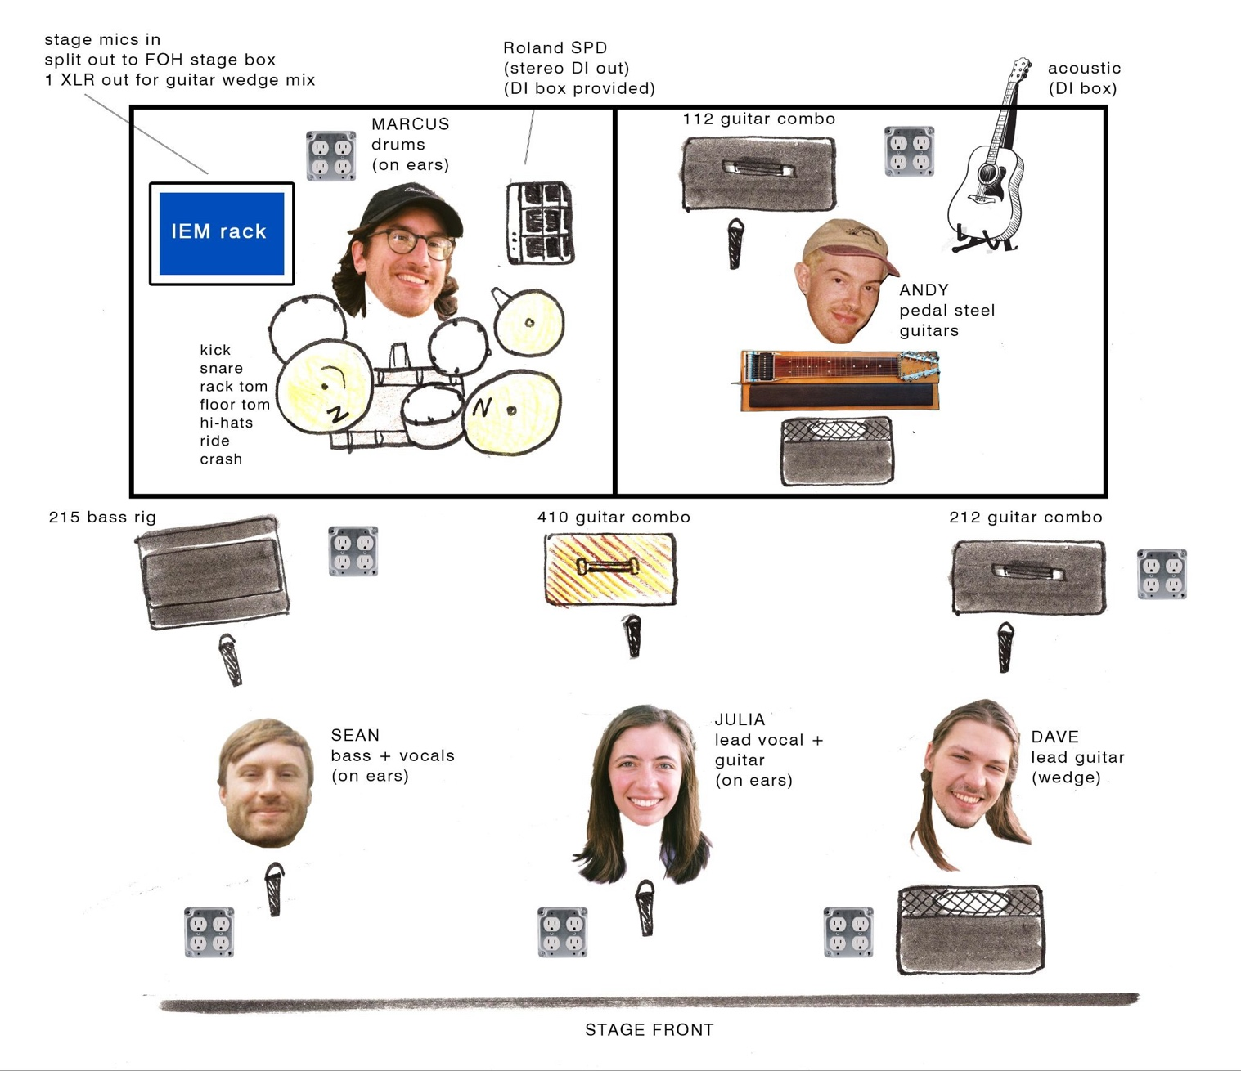
black chs to subsnake
blue chs here
19
18
17
16
15
14
13
12
11
9 +
10
7
6
5
4
3
8
2
1

